AI Documentation - Puppeteer

# Finite State Machine

Minion State Machine Settings Tank State Machine Settings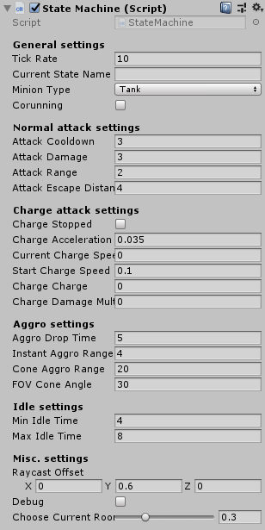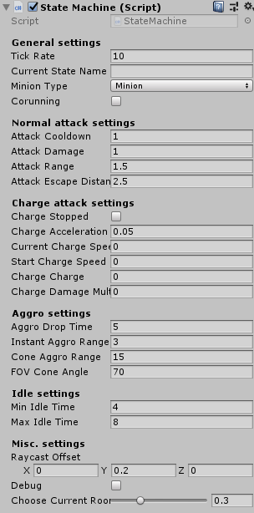

Minions and Tanks share the same Finite State Machine but differ in settings.

# 

## General Settings

#### Tick Rate:

A modified Update where the Update rate can be changed to alleviate the program by only Updating the behaviour at set times instead of every frame.

#### Current State Name:

Shows the name of the current state.

#### Minion Type:

Decides which states should be used depending on the type (minion or Tank).

#### Corunning:

Shows if the Charge Coroutine is running.

## Normal Attack Settings

#### Attack Cooldown:

Decides the time in seconds between attacks.

#### Attack Damage:

Decides the damage each attack does.

#### Attack Range:

Decides the range of the attack.

#### Attack Escape Distance:

Decides the distance a player need to travel away from the minion for the attack to miss.

# 

## Charge Attack Settings

Only the tank use these settings

#### Charge Stopped:

Shows if the Tank is charging or not.

#### Charge Acceleration:

Decides the increase in speed every tick during the charge.

#### Current Charge Speed:

Shows the current charge speed.

#### Start Charge Speed:

Decides the start charge speed.

#### Charge Charge:

Shows the current charge charge, 100 is needed to perform a charge.

#### Charge Damage Multiplier:

Decides how much damage the charge does depending on charge speed.

## Aggro Settings

Only Minions use these settings

#### Aggro Drop Time:

Decides the time in seconds before Minions lose track of players.

#### Instant Aggro Range:

Decides how close a puppet needs to be for the Minion to notice.

#### Cone Aggro Range:

Decides how close a puppet needs to be in the Minions vision cone for the Minion to notice.

#### FOV Cone Angle:

Decides the Field Of View of the Aggro Cone.

## Idle Settings

#### Min Idle Time:

Decides the shortest amount of time a Minion idles before changing state.

#### Max Idle Time:

Decides the longest amount of time a Minion idles before changing state.

## Misc. Settings

#### Raycast Offset:

Offset for every raycast so it doesn’t collide with the floor.

#### Debug:

Decides if debug logs containing debug information show up in the Unity editor.

#### Choose Current Room Chance:

Decides the chance of Minions wandering in to other room. Not used by Tank.

# States

## States for Minions

### The Idle State is shared between Tanks and Minions

#### Attack State:

The Attack state is used by minions and it is the core of the Minion AI. The state follows the player and checks if the player is within its attack-cone and if it is the Minion attacks, this repeats until the target is lost, concealed and/or dead. When that happens the Minion changes state to the Idle State.

#### Return To Spawner State:

If the Minion spawner is attacked by a player all the Minions who has spawned from it returns to the spawner to protect it. If the spawner is destroyed or the Minions can’t find a route the Minions changes to the Idle State.

#### Wander State:

If the Minion have no target they change back and forth between the Idle State and Wander State. They roam the rooms around the Spawner. The Wander State and Idle State always run the Check Proximity coroutine which checks for nearby player and target the closest one within range.

#### Seek State:

Used to make the Minion move to the latest known position of their target. This state also always run the proximity coroutine.

#### Idle State (Minion):

This state runs between almost every state transition, while the minion is idling it waits a random amount of time (between two values) and depending on other variables like if it has a target or the spawner is attacked it changes state accordingly.

## States for Tanks

### The Idle State is shared between Tanks and Minions

#### Big Attack State:

The Tanks variation on the Attack State for Minions. As the Tank can’t lose its target unless the target dies och turns invisible the Big Attack State is the core of the Tank AI. The Tank follows the target and attacks when close enough, this repeats. If the Tank gets 100 Charge Charge the Tank switches state to the Charge Attack State.

#### Charge Attack State:

This state decides the behaviour of the Tanks special attack, the charge. The Tank targets one player and starts the charge attack, running towards the target until it is reached while accelerating. After the charge hits it changes state to the Big Attack State.

#### Idle State (Tank):

The Idle State for the tank is different, all it does is when the Tank has no target it waits until a player enters the same room as the Tank, the Tank is shot or if they get too close then it targets and attacks.